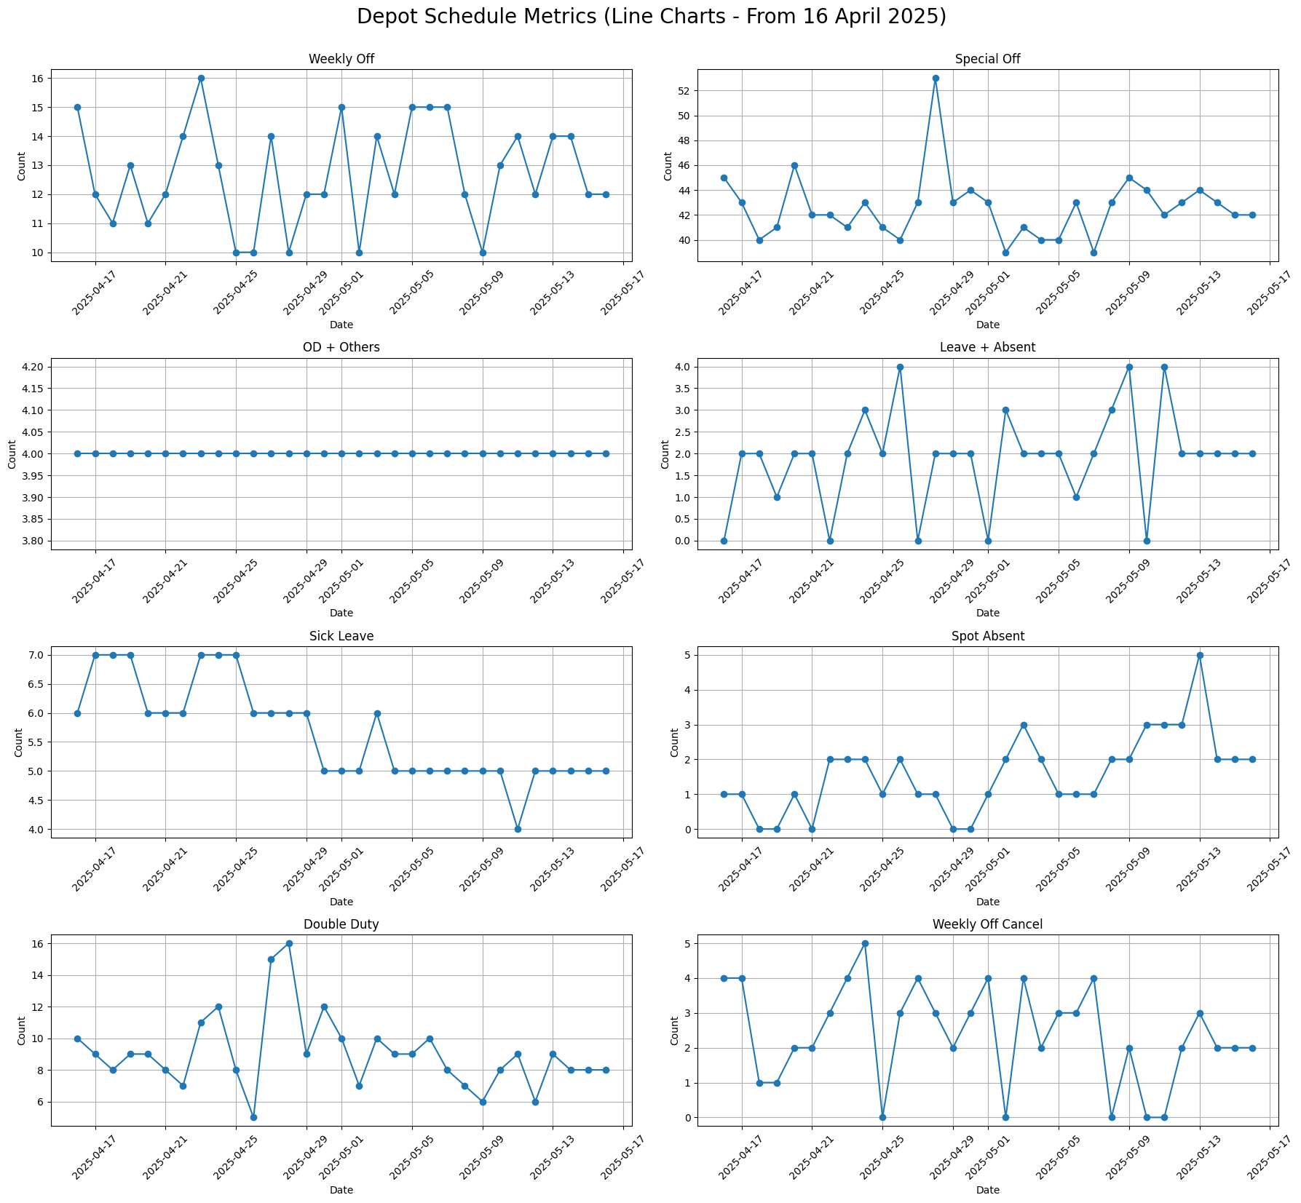

**📊 Written Summary of Trends (From 16 April 2025)**

**1. Weekly Off**

* Fairly consistent, fluctuating mostly between 11 to 15.
* A couple of low dips (~10) and high spikes (~16) indicate slight scheduling imbalances.

**2. Special Off**

* Generally ranges between 40–46, with a sudden **spike to 52** on **April 29**, which is an outlier.
* Indicates one-off events or policy-driven adjustments on that day.

**3. OD + Others**

* Remarkably **stable at ~4**, showing consistent handling or logging of these types of entries.
* No visible trend or variability.

**4. Leave + Absent**

* Modest increase in the middle of the period with peaks at **4 on May 2 and May 10**.
* Drop to **0** on May 5 stands out—possible data anomaly or full attendance.

**5. Sick Leave**

* Begins higher (~6–7) and gradually **declines to 4** towards mid-May.
* Suggests a recovery trend or improved health/attendance post-April.

**6. Spot Absent**

* Starts low (~0–1) and **rises steadily**, peaking at **5 on May 14**.
* Indicates increasing last-minute absenteeism—worth investigating underlying reasons.

**7. Double Duty**

* Peaks at **16 on April 30**, with fluctuating values afterward.
* Reflects irregular workload balancing or driver shortage on certain days.

**8. Weekly Off Cancel**

* Highly volatile; fluctuates between 1 and 5.
* Peaks on **April 29 and May 2**, aligning with high Special Off/Double Duty—suggesting operational adjustments on those days.

**📈 Statistical Insights**

| **Metric** | **Mean** | **Std Dev** | **Min** | **Max** | **Notable Peaks** |
| --- | --- | --- | --- | --- | --- |
| Weekly Off | ~13 | ~1.8 | 10 | 16 | Apr 21, Apr 30 |
| Special Off | ~43 | ~2.5 | 39 | 52 | **Apr 29 (52)** |
| OD + Others | ~4 | ~0.0 | 4 | 4 | None (Stable) |
| Leave + Absent | ~2 | ~1.2 | 0 | 4 | May 2, May 10 |
| Sick Leave | ~5.3 | ~1.0 | 4 | 7 | Apr 17–25 |
| Spot Absent | ~1.7 | ~1.4 | 0 | 5 | **May 14 (5)** |
| Double Duty | ~9.7 | ~3.2 | 5 | 16 | **Apr 30 (16)** |
| Weekly Off Cancel | ~2.6 | ~1.3 | 1 | 5 | Apr 29, May 2 |

**🚨 Anomaly Detection (Key Outliers)**

| **Date** | **Anomaly Metric** | **Description** |
| --- | --- | --- |
| **Apr 29** | Special Off (52) | High spike—policy/event-driven anomaly |
| **Apr 30** | Double Duty (16) | Highest value—possibly linked to Apr 29 |
| **May 2** | Leave + Absent (4), WOC (5) | Simultaneous peaks—potential staff shortage |
| **May 5** | Leave + Absent (0) | Sudden drop—possible misreport or full attendance |
| **May 14** | Spot Absent (5) | High spot absenteeism—flag for review |

**⏱️ Time Series Analysis**

**📌 Time Frame:**

* **Start**: 16 April 2025
* **End**: 17 May 2025
* **Duration**: ~32 days
* **Frequency**: Daily

**📈 Analysis by Metric**

**1. Weekly Off**

* **Trend**: Stable overall with random fluctuations.
* **Seasonality**: Not evident in the short time frame.
* **Volatility**: Low-to-moderate.
* **Stationarity**: Appears stationary; mean/variance don't drift.
* **Observation**: A few noticeable dips (e.g., Apr 21, May 5) may coincide with operational changes.

**2. Special Off**

* **Trend**: Flat with **one significant spike** (Apr 29).
* **Volatility**: Generally low, except for outlier.
* **Mean Reversion**: Returns to baseline after spike.
* **Forecast Insight**: Exclude outlier for better forecasting.

**3. OD + Others**

* **Trend**: **Constant flat line (~4)**.
* **Seasonality**: None.
* **Volatility**: None.
* **Insight**: Time series modeling not applicable due to zero variance.

**4. Leave + Absent**

* **Trend**: Slight upward drift.
* **Volatility**: Moderate; mix of zero and peak values (0 to 4).
* **Potential Seasonality**: Weekly pattern not confirmed due to short range.
* **Stationarity**: May benefit from first-differencing to stabilize.

**5. Sick Leave**

* **Trend**: **Decreasing** (starts high, then stabilizes at 4).
* **Seasonality**: Weak or absent.
* **Volatility**: Low in second half.
* **Model Suitability**: Linear regression or smoothing models can model decline.

**6. Spot Absent**

* **Trend**: **Upward** trend detected.
* **Volatility**: High; spiky.
* **Forecast Insight**: Could signal rising operational issues—worthy of exponential smoothing.

**7. Double Duty**

* **Trend**: Fluctuating with high peak on Apr 30.
* **Volatility**: High.
* **Seasonality**: Not evident.
* **Observation**: Consider peak as operational stress; forecast cautiously.

**8. Weekly Off Cancel**

* **Trend**: No clear direction; high variability.
* **Volatility**: High for a metric with low expected values.
* **Stationarity**: Likely stationary after outlier adjustment.
* **Smoothing Advice**: Moving average or Holt-Winters for smoothing.

**⚠️ Anomaly Detection (Based on Residuals)**

* **Spot Absent**: A spike around **May 14–15** appears above normal bounds.
* **Double Duty**: Significant residuals (~±4) on specific days suggest over-dependence.
* **Leave + Absent**: Irregular peaks—cross-validation with holidays could help refine causes.

**📈 7-Day Forecast (Holt-Winters Method)**

**1. Spot Absent**

* **Forecast Range**: 2 to 3 absentees daily.
* **Insight**: Slightly elevated spot absenteeism expected. May indicate ongoing scheduling or morale issues.

**2. Sick Leave**

* **Forecast Range**: Steady at ~4.4 to 4.6.
* **Insight**: Stable sick leave levels with no upward pressure, indicating control.

**3. Leave + Absent**

* **Forecast Range**: Increasing from 2.0 to around 3.2.
* **Insight**: Slight rise—could be due to planned leaves or external events (e.g., local holidays).

**4. Double Duty**

* **Forecast Range**: Mostly between 6 and 9.
* **Insight**: Lower than peak levels seen earlier (~16). Appears more stable but still above the minimal base load.

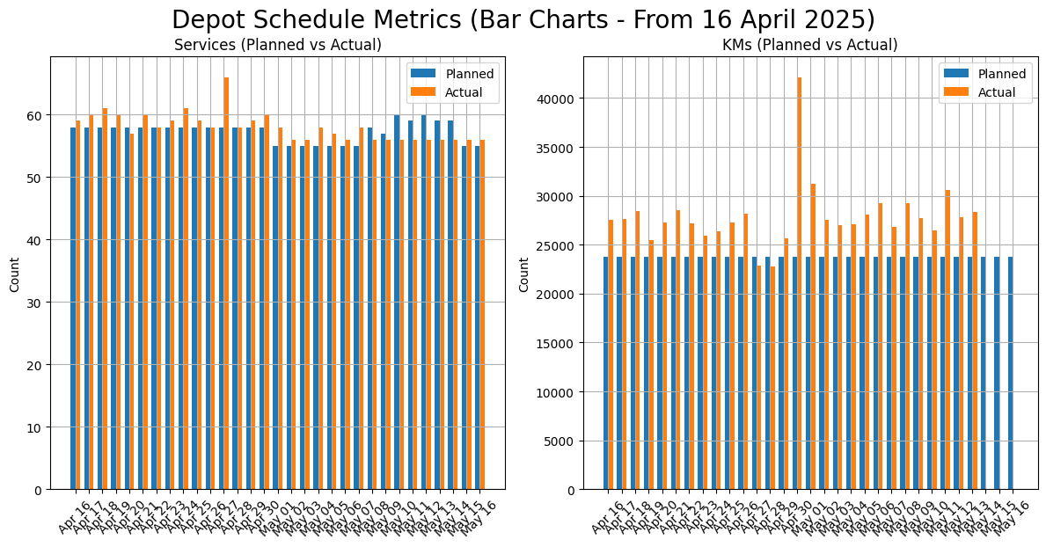

## 📈 Trend Analysis

**🚌 Services (Planned vs Actual)**

| **Aspect** | **Observations** |
| --- | --- |
| **Stability** | Planned services are **highly stable**, mostly between **56 and 60**. |
| **Actual trend** | Actual services follow a similar trend but with **more variability**. |
| **Fluctuations** | Small day-to-day ups and downs are typical—usually within ±2 services. |
| **Outliers** | Notable **spike around April 27**—actual exceeds 65 services. This is **abnormally high**. |
| **End-period trend** | Slight **dip around May 10–13**, possibly due to staff availability or route reductions. |

📌 **Interpretation**:  
Overall alignment between Planned and Actual Services suggests **good operational control**. The single high deviation may point to **reactive scheduling** or **data issues**.

**🚐 KMs (Planned vs Actual)**

| **Aspect** | **Observations** |
| --- | --- |
| **Stability** | Planned KMs are extremely consistent (~24,000–24,500 KMs daily). |
| **Actual trend** | Actual KMs show **higher volatility**—frequently **2,000–5,000 KM above plan**. |
| **Outliers** | Extreme spike around **April 27**, where Actual KMs exceeded **42,000** (vs 24,000 planned). |
| **Overall pattern** | Actual KMs generally **outpace Planned** KMs almost every day. |
| **Consistency** | Despite the variation, there’s a **repeating pattern**—Actual KMs tend to track about **10–20% above plan**. |

📌 **Interpretation**:  
The persistent positive variance in Actual KMs suggests:

* **Route extensions** or **trip overlaps**.
* Possible **inefficiencies** (e.g., diversions, breakdown recovery).
* Need for route audit or verification.

**📊 Summary Table of Trends**

| **Metric** | **Planned Trend** | **Actual Trend** | **Notable Spikes** | **Stability Level** |
| --- | --- | --- | --- | --- |
| **Services** | Flat, minor dip in May | Tracks closely, ±2 range | Apr 27 (~67) | High |
| **KMs** | Flat, highly consistent | Volatile, often higher | Apr 27 (~42k) | Moderate |